Soh Su Xian Alicia | A0114334U





ATAP Final Project Report | AY2016/17

JTC Corporation (9th May – 21st Oct 2016)

**Advanced Technology Attachment Programme (ATAP)**

**Final Project Report**

**at**

**JTC Corporation**

**Reporting Period:**

**05/2016 (9th May 2016) to 10/2016 (21st Oct 2016)**

by

Soh Su Xian Alicia

Department of Information Systems

School of Computing

National University of Singapore

2016/2017

Project Title: JTC Contracts Data Visualisation and Analytics Project (II)

Project ID: A970916

Project Supervisor: Prof Bhojan Anand

# Summary

The three projects that I am tasked to complete are as follows:

1. CNPD Qlik Project
2. Internet of Things (IoT) – Motion Sensor for Paper Towel
3. My JTC Project (Encouraging the use of shared spaces)

For CNPD Qlik project, resultant dashboards are created for Contracts and Procurement Division (CNPD) using desktop version software called Qlik Sense. Qlik Sense is a Business Intelligence software for data visualization, guided analytics, embedded analytics and reporting. Requirements (e.g. business questions) as well as source data files (excel files from PROMPT (Procurement & Project Mgt Sys) or manual entry excel data files) were gathered from CNPD for the creation of the Qlixk dashboards. Qlik training sessions were conducted too to users from different departments to teach them the functions that Qlik provide.

JTC is looking into implementing Internet of Things (IoT) systems within the company building to make the building smarter. A proof of concept (POC) motion sensor setup has been developed and deployed into the paper towel roll machine. The purpose of developing this POC is to aid and lessen the workload of the workers who are in charge of replacing the paper towel in the paper towel roll machine. The POC is developed using HC-SR04 distance motion sensor which is connected to an ESPresso Lite V2.0 board programmed using Arduino IDE and the output is sent to Raspberry Pi.

Last but not least, working together with other interns at JTC, My JTC Project involves finding solutions that can improve JTC. For my group’s JTC Project, we were tasked to find solutions that can help to encourage the use of shared spaces.

Subject Descriptors:

D.2.1 Requirements

H.3.5 Online Information Services

H.5.2 User Interface

I.2.9 Robotics

Keywords:

Qlik Sense, Raspberry Pi, Motion Sensor, Internet of Things, MQTT, Data Analytics

Implementation Software and Hardware:

Dell PC, MS-Windows, MS-DOS, Qlik Sense, Raspberry Pi, ESPresso Lite V2.0, ESP8266, HC-SR04, Arduino IDE, Mosquitto MQTT

# Acknowledgement

The internship opportunity I have with JTC Corporation is a great chance for learning and professional development. I consider myself a very lucky individual as I was provided with an opportunity to be a part of the company. I am also very grateful for having the chance to meet so many wonderful people and professionals who led me though this internship period.

I would like to express my deepest gratitude and special thanks to my supervisors, Mr Gary How, Mr Shangru Ng and Miss Lillan Ba, whom in spite of their busy schedules, took time out to hear, guide and keep me on the correct path and allow me to carry out my project at their esteemed organization. It is my radiant sentiment to place on record my best regards, deepest sense of gratitude to them for their careful and precious guidance which were extremely valuable for my study both theoretically and practically.

I would also like to express my deepest thanks to Deputy Director, Mr Roland U, for taking part in the decision making and giving me the opportunity to work together with IT Department. I am also grateful for the advices and guidance I was given with through my internship period.

I perceive as this opportunity as a big milestone in my career development. I will strive to use gained skills and knowledge in the best possible way, and I will continue to work on their improvement, in order to attain desired career objectives. I hope to continue cooperation with JTC Corporation in the future.

Sincerely,

Soh Su Xian Alicia

Intern, JTC Corporation, IT Department (ITD)

3rd October 2016

# Table of Contents

Summary 2

Acknowledgement 4

Table of Contents 5

1. Introduction 6

1.1 Background and Organisational Structure of Host Organisation (JTC) 6

1.2 Principal Activities of Host Organisation (JTC) 6

1.3 Training Programme with Host Organisation (JTC) 7

1.4 Position of Host Unit Within Host Organisation (JTC) 7

2. Training Schedule and Assignments 7

2.1 Training Schedule by Month for The Entire Training Period 7

2.2 Training Assignments Completed in 1st Month 9

2.3 Training Assignments Completed in 2nd Month 10

2.4 Training Assignments Completed in 3rd Month 10

2.5 Training Assignments Completed in 4th Month 11

2.6 Training Assignments Completed in 5th Month 12

2.7 Training Assignments Completed in 6th Month 13

3. Knowledge and Experience Gained 13

3.1 Technical Knowledge Gained from Assignments 13

3.2 Organisational/ Industry Experience Gained from Assignments 14

3.3 Areas of Applicability of Knowledge and Experience Gained 14

4. Conclusions 14

4.1 Summary of Work Completed and Training Received 14

4.2 Problems Faced 16

4.3 Assessment of Training Experience and Concluding Remarks 16

References 17

Appendix A: Qlik Sense 18

Appendix B: Arduino IDE 20

Student Log Sheet 21

ATAP Report Clearance Form 31

# 1. Introduction

## **1.1 Background and Organisational Structure of Host Organisation (JTC)**

Before the inception of JTC, industrial land planning and development was handled by the Economic and Development Board of Singapore (EDB). The EDB’s goal was to attract foreign investment and spearhead Singapore’s industrialisation programme. Through EDB’s efforts, it was able to attract investments worth S$178 million at the end of the first phase of development for Singapore’s first industrial estate, the Jurong Industrial Estate. After independence in 1965, the government sought to hand over the management of the industrial estates to a specialist agency. Thus, on 1 June 1968, JTC was set up under the Jurong Town Corporation Act as a statutory board under the Ministry of Trade and Industry.

To date, JTC is Singapore’s leading provider of industrial space solutions, offering a wide range of industrial and business facilities tailored to suit all types of manufacturing and related operations. Over the past three decades, JTC has developed some 8,000 hectares of industrial land and 4 million square metres of ready-built factories for more than 7,000 local and multinational companies. Among these are specialised parks and facilities for high technology and life sciences industries. These include the one-north cluster (Biopolis, Fusionopolis, Mediapolis, LaunchPad (Blk 71)), International and Changi Business Parks and Jurong Island.

In following Singapore’s strategic direction and emphasis on the exploitation of the benefits of IT in industry and the creation of a smart nation, JTC is ramping up its operations and processes to suit the changing environment. As JTC’s customers start to embrace and include IT-centric processes in their business, JTC also prepares itself for the future in order to cater to those needs. (Jurong Town Corporation (JTC), 2016)

## **1.2 Principal Activities of Host Organisation (JTC)**

Over the decades, JTC pioneered cutting-edge industrial infrastructure solutions to meet the evolving needs of companies with each phase of industrialisation.

Today, JTC continues to break new ground with pioneering projects that not only support the changing needs of today's industries but also anticipate the future needs of new industries. The Jurong Rock Caverns look to subterranean depths to optimise land use; Tukang Innovation Park support the growth of new industry cluster in innovation activities; the Jurong Island Version 2.0 initiative plans to enhance competitiveness of the chemicals hub.

JTC's work exemplifies the vital role of infrastructure in economic transformation, and the need to continually push the envelope of innovation. As Singapore transforms itself for the future, JTC will continue to develop specialised land and new innovative space to support and catalyse new industry clusters, in order to support the growth and transformation of industries and enterprises. (Jurong Town Corporation (JTC), 2016)

## **1.3 Training Programme with Host Organisation (JTC)**

The internship spans for a total of six months from 9th May 2016 to 21st October 2016. For six months at JTC, the training for this internship was mostly self-initiated learning besides a few scheduled workshops. One of the scheduled workshops was the Qlik Workshop which served to introduce as well as get me familiarised with the Qlik Sense software that I will be utilising for one of my projects. I have also attended meetings as well as presentations. Such training opportunities allowed me to gain more knowledge and experience about the corporate world as well as learn soft skills that are essential in the corporate world.

## **1.4 Position of Host Unit Within Host Organisation (JTC)**

The host unit that I am being placed under in is Information Technology Department (ITD). There are a total of 4 groups in JTC organisation and ITD is under the Corporate, Policy and Planning Group. Under the ITD, there are several sub departments and some examples are Application Support Dept (ASD), Business Systems Dept (BSD) and Smart Estates Department (SED). I am being placed in the SED (Smart Estate Department).

# 2. Training Schedule and Assignments

## **2.1 Training Schedule by Month for The Entire Training Period**

Projects:

1. CNPD Qlik

2. Motion Sensor for Paper Towel

3. My JTC Project

|  |  |
| --- | --- |
| Month | Work Schedule |
| May | * Attended project meeting with my supervisors to discuss about the project details that I will be doing during the first three months of the internship   P1:   * Attended Qlik Sense Workshop to learn about Qlik Sense Software * Attended a meeting together with CNPD (Contracts and Procurement Department) to discuss and understand more about the requirements of the projects   P2:   * Attended a meeting with my supervisor in charge of this project to discuss as well as to be introduced to the various equipment that I will be using for this project |
| June | P1:   * Continue working on the project – edit and update the dashboard based on the comments and feedback received from CNPD after every meeting * Conducted a mass training session for CNPD to teach them how to use Qlik Sense (e.g. how to create a simple dashboard as well as how to share the dashboards that they have created with other colleagues)   P2:   * Worked on Raspberry Pi to create a blinking LED project to learn about the basics of Raspberry Pi on my own * Worked on HC-SR04, ESPresso Lite V2.0, Arduino IDE and Raspberry Pi to develop a distance sensor to be deployed for the paper towel project |
| July | P1:   * Continue to work on the Masterlist dashboard based on the comments and feedback received from CNPD * Presented the CNPD Masterlist Dashboard to CNPD as well as CNPD Deputy Director on the 22nd July   P2:   * Successfully deployed the motion sensor into the paper towel machine – Able to send data from the HC-SR04 sensor to the Raspberry Pi, send SMS directly from the Raspberry Pi and also, store the data into dynamoDB   P3:   * Attended my first short meeting together with my JTC Project intern groupmates to discuss on the solutions that can encourage staffs to use more of JTC shared spaces * Presented my JTC Project solutions during the Intern’s Closing Ceremony |
| August | P1:   * Continue to clean up the Masterlist dashboard in order to baseline the dashboard * Stared working on Qlik CNPD project Technical Documentation v0.1   P2:   * Worked on Motion Sensor for Paper Towel Technical Documentation v1.0. Final Version of Motion Sensor for Paper Towel Technical Documentation is v1.1 |
| September | P1:   * Optimised the Masterlist dashboards (e.g. removed all hardcoded expressions, improved the dashboards by adding spaces in between visualisations, adding headers to the visualisations and adding descriptions to the dashboards). Sent the finalised dashboards to my supervisors as well as to the CNPD Department. * Continued working on Qlik CNPD project Technical Documentation v1.0. Final Version of Qlik CNPD Project Technical Documentation is V1.0. |
| October | P1:   * Conducted another Qlik Training session for CNPD Department for recap as well as to thoroughly answer any queries * Prepared a Qlik Sense V3.0 help guide word document for CNPD as well as Reclamation Department * Conducted a Qlik training session for Reclamation Department on the 3rd October to teach the users about the functions that Qlik provide. Provided the users the help guide word document for reference |

## **2.2 Training Assignments Completed in 1st Month**

|  |  |
| --- | --- |
| **Week** | **Training Assignments Completed** |
| **1**  **(9th May – 13th May)** | P1:   * Attended Qlik Sense Workshop on 10th May to learn about Qlik Sense Software that I will be using for one of my projects (CNPD Qlik Project)   Attended a meeting together with my supervisor Gary How on 11th May to discuss about the project details that I will be doing as well as the timeline of my internship   * Played around with Qlik Sense software (read through the tutorial and basics) to get hold of the software before I start using it for one of my projects |
| **2**  **(16th May – 20th May)** | P1:   * Attended a meeting on 17th May together with the Contracts department to understand more as well as get to know more about the requirements they want for one of the projects (CNPD Qlik) |
| **3**  **(23rd May – 27th May)** | P2:   * Had a meeting with my other supervisor Shangru on 23rd May to discuss about the CHOPE Sensor project as well as the Paper towel roll sensor project. Got introduced to Raspberry Pi, Arduino and ESPresso |
| **4**  **(30th May – 31st May)** | P1:   * Received data from CNPD for the CNPD Qlik project. Cleaned the data and started working on creating the numerous dashboard that CNPD has requested for the project * Continued with CNPD Qlik project. Improved the Qlik boards. Contacted Cassandra from Contracts Department to clarify my doubts with regards to the project |

## **2.3 Training Assignments Completed in 2nd Month**

|  |  |
| --- | --- |
| **5**  **(1st June – 3rd June)** | P1:   * Attended a Qlik dashboard discussion on the 9th June to present to CNPD department the dashboards that my intern colleague and me has created. We received feedback and comments from them on how to further improve the dashboard. Finally we sent to them the dashboard files for them to interact with. |
| **6**  **(13th June – 17th June)** | P2:   * Worked on Raspberry Pi to start on the motion sensor project. Did Python programming on a programming application called Geany on the Raspberry Pi to code a program to get the motion sensor to work (e.g. to retrieve information whether motion is detected). * Researched on the internet on ways by which I will be able to send information via sms if motion is detected on the motion sensor. |
| **7**  **(20th June – 24th June)** | P2:   * Worked on ESPresso Lite V2.0, Arduino IDE and HC-SR04 Distance sensor for the motion sensor paper towel project * Researched and sourced the internet for information on how to work the HC-SR04 sensor with ESPresso Lite V2.0 board |
| **8**  **(27th June – 30th June)** | P1:   * Conducted a mass training session on the 29th June for Contracts and Procurement Department (CNPD) on the Qlik software. Taught the users on how to create a simple dashboard as well as how to share the dashboard with colleagues   P2:   * Managed to get the ESPresso Lite V2.0 board, ESP8266, HC-SR04 and Arduino IDE to work together to obtain the sensor information * Managed to send sensor data from ESPresso Lite V2.0 board, ESP8266 to Raspberry Pi via Mosquitto MQTT Broker |

## **2.4 Training Assignments Completed in 3rd Month**

|  |  |
| --- | --- |
| **9**  **(1st July – 8th July)** | P1:   * Attended a mass briefing on the 4th of July and 7th July on the usage of VISOR * Attended a meeting on the 5th July together with CNPD Department to discuss on the dashboard as well as to receive comments and feedback |
| **10**  **(11th July – 15th July)** | P1:   * Masterlist data received from CNPD on the 8th July – using this new updated data to re-create the dashboard * Attended meeting with CNPD on the 13th July to receive comments and feedback for the dashboard * Re-designed the dashboard based on the comments and feedback received and prepare for the final presentation of the dashboard on the 20th July   P2:   * Deployed the motion sensor onto the paper towel machine. Currently working on sending the SMS part where the raspberry pi sends SMS to the respective phone numbers * Testing of battery using EM490 Digital Multimeter to see how long the battery can last on the motion sensor – when the meter reads less than 3.3V, it means that the motion sensor will stop working/ producing sensor readings   P3:   * Attended a short meeting together with my other groupmates interns to discuss on the Interns’ Project – Encouraging Use of Shared Spaces in JTC Summit |
| **11**  **(18th July – 22nd July)** | P1:   * Attended a meeting on 19th July for update on the CNPD Qlik Dashboard project together with my supervisors and Deputy director, Roland U * Attended a meeting on 20th July together with CNPD to receive feedback and comments for Masterlist dashboard before the final presentation with CNPD Director on the 22th July * Completed CNPD Masterlist dashboard on the 21st July and also created an excel document to document on the various dashboards created, the dashboards descriptions as well as the excel source file used * Presented the CNPD Masterlist dashboard to CNPD Director on the 22nd July   P3:   * Completed the powerpoint slides for my group’s Interns’ Project – Encouraging Use Of Shared Spaces in JTC Summit |
| **12**  **(25th July – 29th July)** | P1:   * Follow up on the final presentation on 22nd July for CNPD Qlik Project – Source for methods to ensure that the path of the data file in Qlik Sense can be accessed and is linked to everyone, request for the rest of the data files to be sent over for the creation of the remaining CNPD dashboards   P3:   * Attended JTC Internship Appreciation Ceremony and presented my group’s project on Encouraging The Use of Shared Spaces |

## **2.5 Training Assignments Completed in 4th Month**

|  |  |
| --- | --- |
| **13**  **(1stAug – 5th Aug)** | P1:   * Worked on CNPD Qlik technical documentation as well as motion sensor for toilet paper technical documentation and proposal paper |
| **14**  **(8th Aug – 12th Aug)** | P1:   * Finalised 1st draft of CNPD Qlik technical documentation on the 8th August and sent to my other intern colleague for editing * Cleaned up the Masterlist manual excel file, updated and refined the Masterlist dashboards. Sent the updated Masterlist qvf files, cleaned up version of the Masterlist excel file as well as the Qlik extensions used for the Masterlist dashboards to CNPD as well as my supervisors * Tried out the method of saving the data source file into a specific folder (C:/App/) that can be located in everyone’s laptops via Qlik. Tested out and concluded that it work |
| **15**  **(15th Aug – 19th Aug)** | P1:   * Helped Guo An (from CNPD) to solve several Qlik issues that he faced (e.g. Data loading error, Qlik expression function issues) * Qlik Sharepoint method: Testing of whether saving the data source file in a Sharepoint folder can be located in everyone’s laptop via Qlik. * Qlik Map Extension: Testing of all the Qlik Sense Map extensions from Qlik Branch website. Tested out and concluded that Google Maps extensions on Qlik Sense do not work on Qlik dashboards anymore as Google Map has updated their API |
| **16**  **(22nd Aug – 31st Aug)** | P1:   * Created the baseline dashboard for Masterlist (using August Masterlist excel data sent by CNPD). Sent the baseline dashboard to CNPD.   P2:   * Listed down the total inventory (equipment used and unused) for the paper towel motion sensor project in a word document. |

## **2.6 Training Assignments Completed in 5th Month**

|  |  |
| --- | --- |
| **17**  **(1st Sept – 9th Sept)** | P1:   * Optimised the Masterlist dashboard (e.g. removed all hardcoded expressions, improved the dashboard by adding spaces in between visualisations, adding headers to the visualisations and adding descriptions to the dashboards) and sent to my supervisor on 7th September * Did a quick installation of Qlik Sense V3.0 on CNPD various HODs as well as various staff laptops on 8th September * Updated Qlik Technical Specifications based on the initial comments from the review of the initial version (0.1) for Technical Specifications (on 02/09/2016). |
| **18**  **(12th Sept – 16th Sept)** | * Started working on presentation slides for October presentation - Decided that for Qlik Project, presentation slides will be done using Qlik Sense Desktop Software while for the motion sensor project, presentation slides will be done using Powerpoint with JTC slides. |
| **19**  **(19th Sept – 23rd Sept)** | P1:   * Helped Guo An with creating the dashboard CNPD Divison Meeting_August 2016.qvf |
| **20**  **(26th Sept – 30th Sept)** | * Edited presentation slides for the 6th October final presentation   P1:   * Prepared a Qlik Sense V3.0 help guide word document for CNPD department as well as Reclamation Department for their own references |

## **2.7 Training Assignments Completed in 6th Month**

|  |  |
| --- | --- |
| **21**  **(3rd Oct – 7th Oct)** | * Edited and refined the Qlik presentation slides for Oct 6th presentation   P1:   * Conducted another Qlik training session for CNPD Department on the 5th October * Held a Qlik training session for Reclamation Department on the 3rd October to teach them about Qlik * Added in a section on “Sharing of dashboards” in the word document file (guide help book) for the Qlik training session |
| **22**  **(10th Oct – 14th Oct)** | * Prepared all relevant final documents e.g. finalised report (Technical Specification V1.0), ATAP Final Report and the documents and files used for the final presentation all into a zip folder to be sent to my supervisor Gary How   P1:   * Discussed with one of my supervisors, Gary How, on video ideas to promote the usage of Qlik Sense in JTC |
| **23**  **(17th Oct – 21st Oct)** | P1:   * Conducted an individual Qlik Sense training session for Yu Ding on the 20th October |

# 3. Knowledge and Experience Gained

## **3.1 Technical Knowledge Gained from Assignments**

Through the past six months in ITD at JTC, I have gained numerous technical skills. Working with Qlik Sense for the CNPD Qlik project has allowed me to gain experience in using Qlik Sense Software (Desktop version). In addition to the built in functions in Qlik Sense, I have also learnt how to script out specific functions that allows me to edit and vary the built in functions in order to suit the requirements that CNPD requested for their dashboards (Refer to Appendix A). I have also learnt about creating dashboards – how to make the dashboard look aesthetically pleasing and what type of visual charts to use for different purposes. I was also fortunate enough to pass on the skills that I have learnt through using Qlik onto other users from CNPD as well as Reclamation Department. Through the motion sensor projects, I have also learnt how to use Arduino IDE together with Python Language to create simple projects such as connecting a LED light to the Arduino UNO board or ESPresso Lite V2.0 board and making the LED light blink. I have managed to successfully connect various sensors (e.g. HC-SR04 distance sensor, DHT-22 Temperature/Humidity sensor, PIR sensor, Loudness Sensor v0.9b) to the Arduino UNO as well as ESPresso Lite V2.0 board and being able to obtain the data readings from the various sensors (Refer to Appendix B).

## **3.2 Organisational/ Industry Experience Gained from Assignments**

I have also gained organisational/ industry experience through the past six months at JTC. Through attending numerous events as well as meetings, I learnt about how formal meetings are conducted and how corporate events are run. I have also understood the importance of teamwork - working together with colleagues and helping each other out to lighten the workload when another is busy with work. I have also learnt to be independent and to source for my own resources instead of seeking my supervisors for help in completing the projects. I have also learnt how to take initiative at work. For example, my other intern colleague and I have to send numerous reminders to prompt CNPD to send the data files that were required for the creation of the dashboards on Qlik. I have also gained confidence in communicating with other users through the many training sessions that I have conducted for Qlik Sense V3.0 Desktop Software.

## **3.3 Areas of Applicability of Knowledge and Experience Gained**

Qlik Sense software is a Business Intelligence software that can be utilised in any areas that requires data visualization, guided analytics, embedded analytics and reporting. As for motion sensors, the knowledge that I have gained through using Arduino IDE, coding in Python Language and the usage of the various equipment (to develop the POC) are a good start to creating other more intricate systems.

# 4. Conclusions

## **4.1 Summary of Work Completed and Training Received**

Project 1: CNPD Qlik

* Attended Qlik Sense Workshop on 10th May to learn about Qlik Sense Software that I will be using for one of my projects (CNPD Qlik Project)
* Attended a meeting on 17th May together with the Contracts department to understand more as well as get to know more about the requirements they want for one of the projects (CNPD Qlik)
* Conducted a mass training session on the 29th June for Contracts and Procurement Department (CNPD) on the Qlik software. Taught the users on how to create a simple dashboard as well as how to share the dashboard with colleagues
* Masterlist data received from CNPD on the 8th July – using this new updated data to re-create the Qlik dashboard
* Presented the CNPD Masterlist dashboard to CNPD Deputy Director on the 22nd July
* Finalised and Optimised Masterlist dashboards and sent to my supervisor as well as CNPD on the 7th September
* Worked on first draft of Qlik Technical Specifications and came up with v0.1 on the 8th August. Updated Qlik Technical Specifications to the current version V1.0 based on the initial comments from the review of the initial version (0.1) for Technical Specification.
* Conducted the Qlik training session on the 3rd October with users from Reclamation Department.
* Conducted another Qlik training session for CNPD Department on the 5th October.
* Created and sent to CNPD and Reclamation Department a Qlik Sense V3.0 help guide word document for references.

Project 2: Motion Sensor for Paper Towel

* Had a meeting with my other supervisor Shangru on 23rd May to discuss about the CHOPE Sensor project as well as the Paper towel roll sensor project. Got introduced to Raspberry Pi, Arduino UNO and ESPresso Lite V2.0 Board
* Worked on Raspberry Pi to start on the motion sensor project. Did Python programming on a programming application called Geany on the Raspberry Pi to code a program to get the motion sensor to work (e.g. to retrieve information whether motion is detected).
* Managed to get the ESPresso Lite V2.0 board, ESP8266, HC-SR04 and Arduino IDE to work together to obtain and send sensor information. Deployed the motion sensor onto the paper towel machine.
* Testing of battery using EM490 Digital Multimeter to see how long the battery can last on the motion sensor – when the meter reads less than 3.3V, it means that the motion sensor will stop working/ producing sensor readings
* Worked on Motion Sensor for Paper Towel Technical Specifications - Listed down the total inventory (equipment used and unused) for the paper towel motion sensor project in a word document. Final version of the technical specifications is V1.1.

Project 3: My JTC Project

* Attended a short meeting together with my other groupmates interns on the second week of July to discuss on the Interns’ Project – Encouraging Use of Shared Spaces in JTC Summit
* Completed the powerpoint slides on the third week of July for my group’s Interns’ Project – Encouraging Use Of Shared Spaces in JTC Summit. Presented my group’s project on Encouraging The Use of Shared Spaces during the JTC Internship Appreciation Ceremony

## **4.2 Problems Faced**

Project 1: CNPD Qlik

* The data received from CNPD for Masterlist dashboard was not clean and time was required for cleaning the data. However, despite a simple cleaning of the data, there are still a lot of room for cleaning. For example, there were inconsistency with the data - ‘on track’, ‘On Track’ and ‘On track’ were not consistent even though they were referring to the same thing.
* CNPD were unsure of their requirements and thus, it took many meetings and many hours of discussion before coming to the resultant dashboard that was presented during the presentation with CNPD Director on the 22nd July
* Some of the business questions for the dashboard that CNPD requested for were not able to be produced due to the limitations of Qlik as well as there were a lack of data provided by CNPD

Project 2: Motion Sensor for Paper towel

* Had no prior knowledge on how to work on the equipment required for this project. Nevertheless, got introduced to Raspberry Pi, Arduino UNO and ESPresso Lite V2.0 Board during the first meeting
* Did a lot of research on my own during work hours as well as leisure time on how to get the ESPresso Lite V2.0 board, ESP8266, HC-SR04 and Arduino IDE to work together to create the end product of a motion sensor for the paper towel machine

## **4.3 Assessment of Training Experience and Concluding Remarks**

Sufficient and relevant training were provided for Qlik CNPD project and adequate resources can be found online on how to utilise Qlik functions as well as script out relevant functions to suit CNPD requirements for the dashboards. On the other hand, there were relatively fewer training provided for the motion sensor projects. Nevertheless, resources could be found online and with the help of my supervisor, Shangru, and my other intern colleague, the motion sensor for toilet project was successfully deployed.

All in all, the three projects (CNPD Qlik, Paper towel Motion Sensor and My JTC Project) that I have worked on allowed me to gain technical skills that I am unable to learn in school. Through working on these projects at JTC, I have also gained invaluable soft skills that will definitely be helpful for me in the future.

# References

Jurong Town Corporation (JTC). (4 April, 2016). *About JTC*. Retrieved from JTC Corporation: http://www.jtc.gov.sg/about-jtc/pages/default.aspx

# Appendix A: Qlik Sense

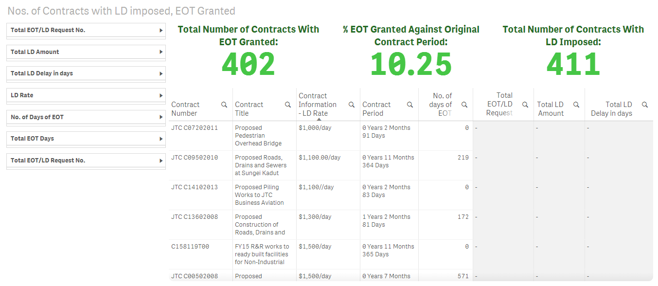

Figure A1. Dashboard in Qlik Sense on the No. of Contracts with LD imposed, EOT Granted

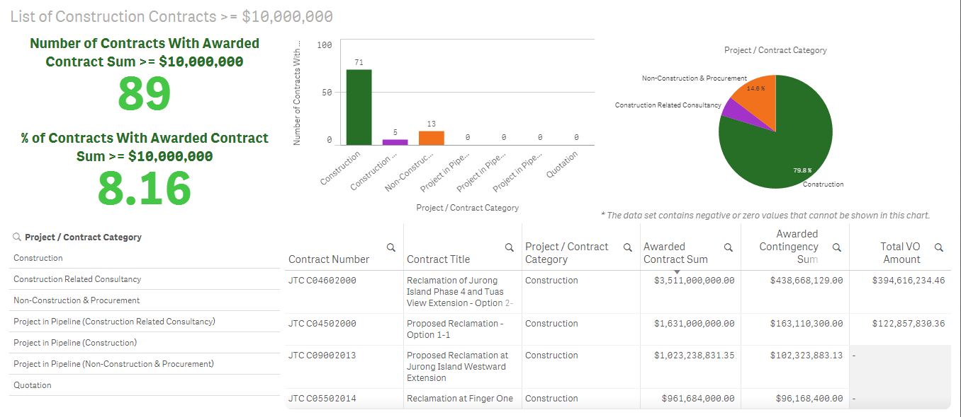

Figure A2. Dashboard in Qlik Sense on the List of Construction Contracts >= $10,000,000

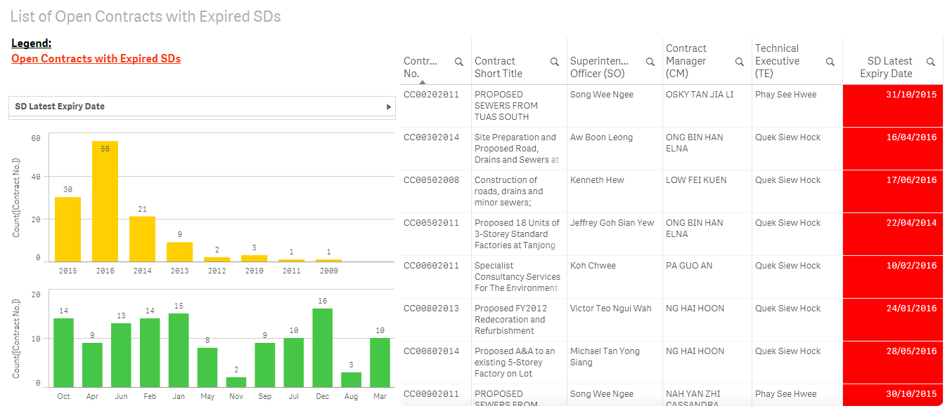

Figure A3. Dashboard in Qlik Sense on the List of Open Contracts with Expired SDs

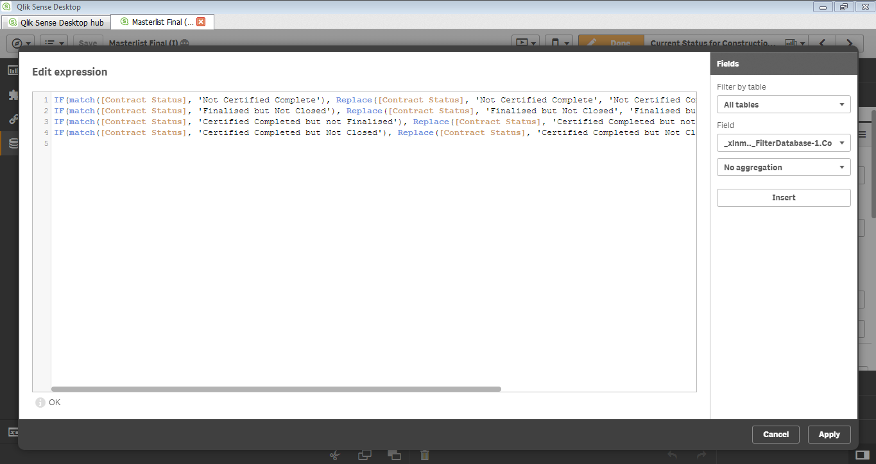

Figure A4. Scripting an expression in Qlik Sense

# Appendix B: Arduino IDE

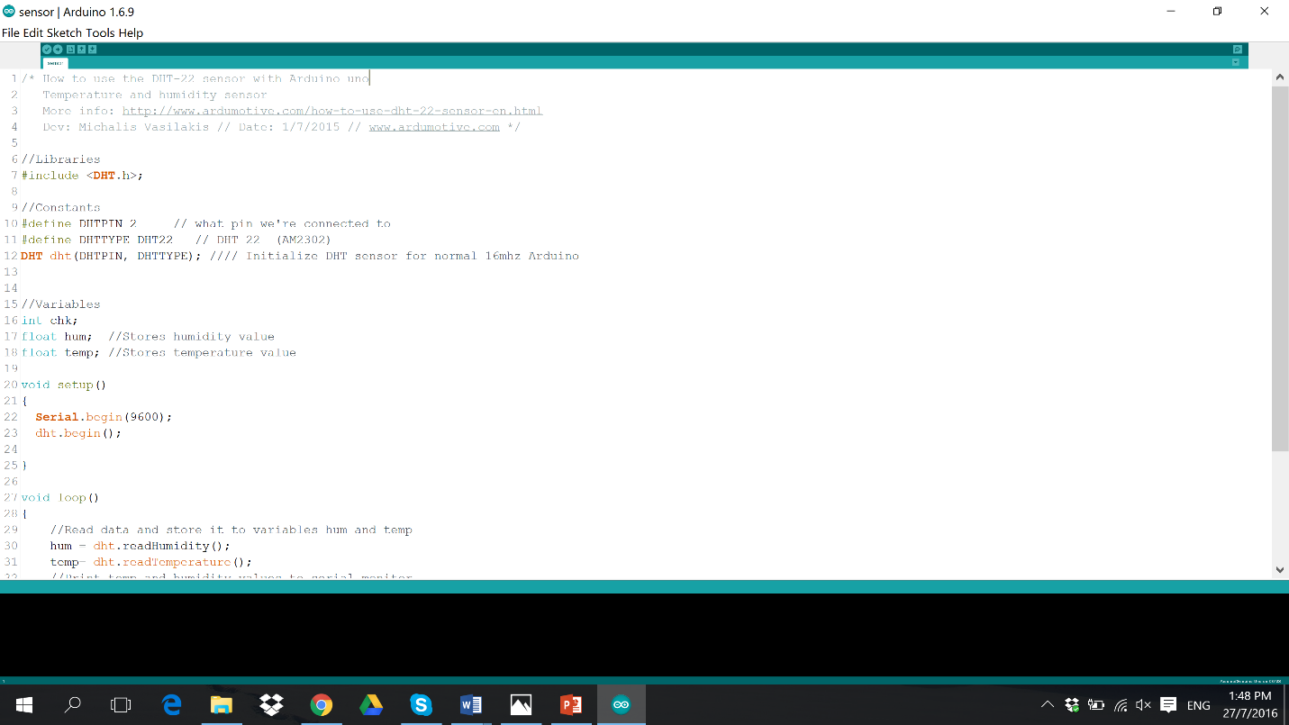

Figure B1. Arduino IDE Python code for the DHT-22 Temperature/ Humidity Sensor

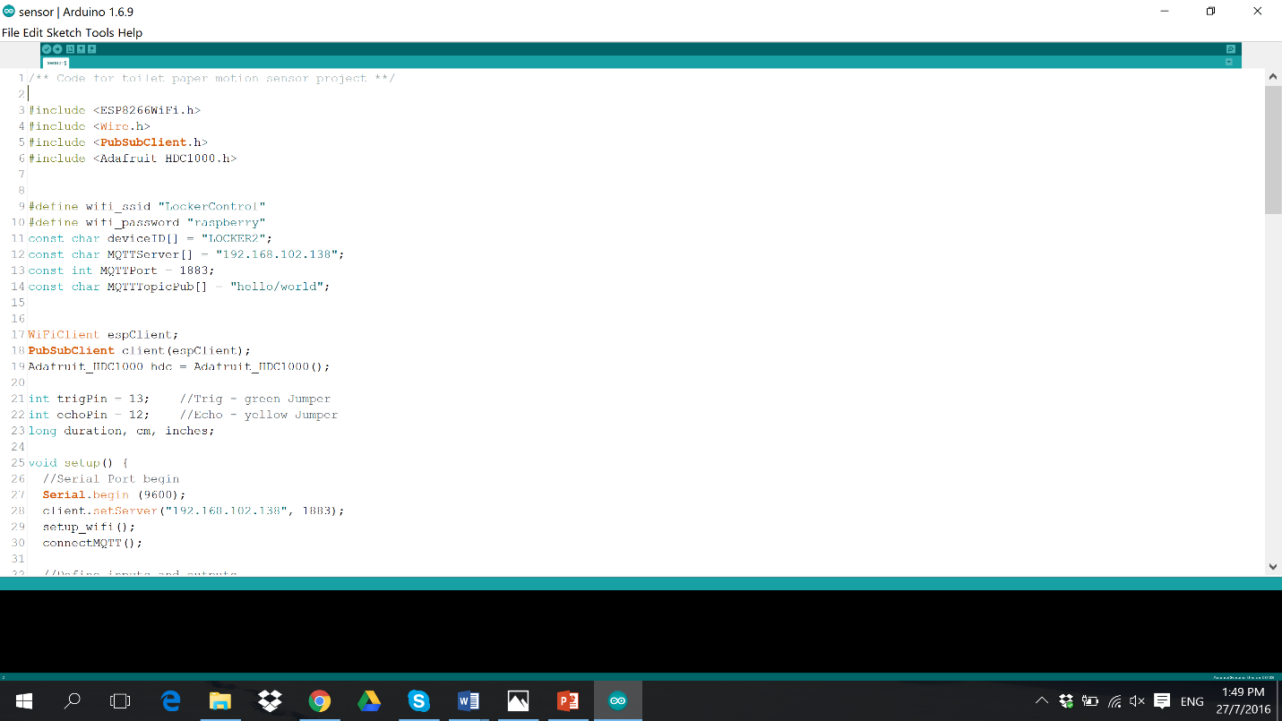

Figure B2. Arduino IDE for the HC-SR04 Distance sensor used for the paper towel motion sensor project

# Student Log Sheet

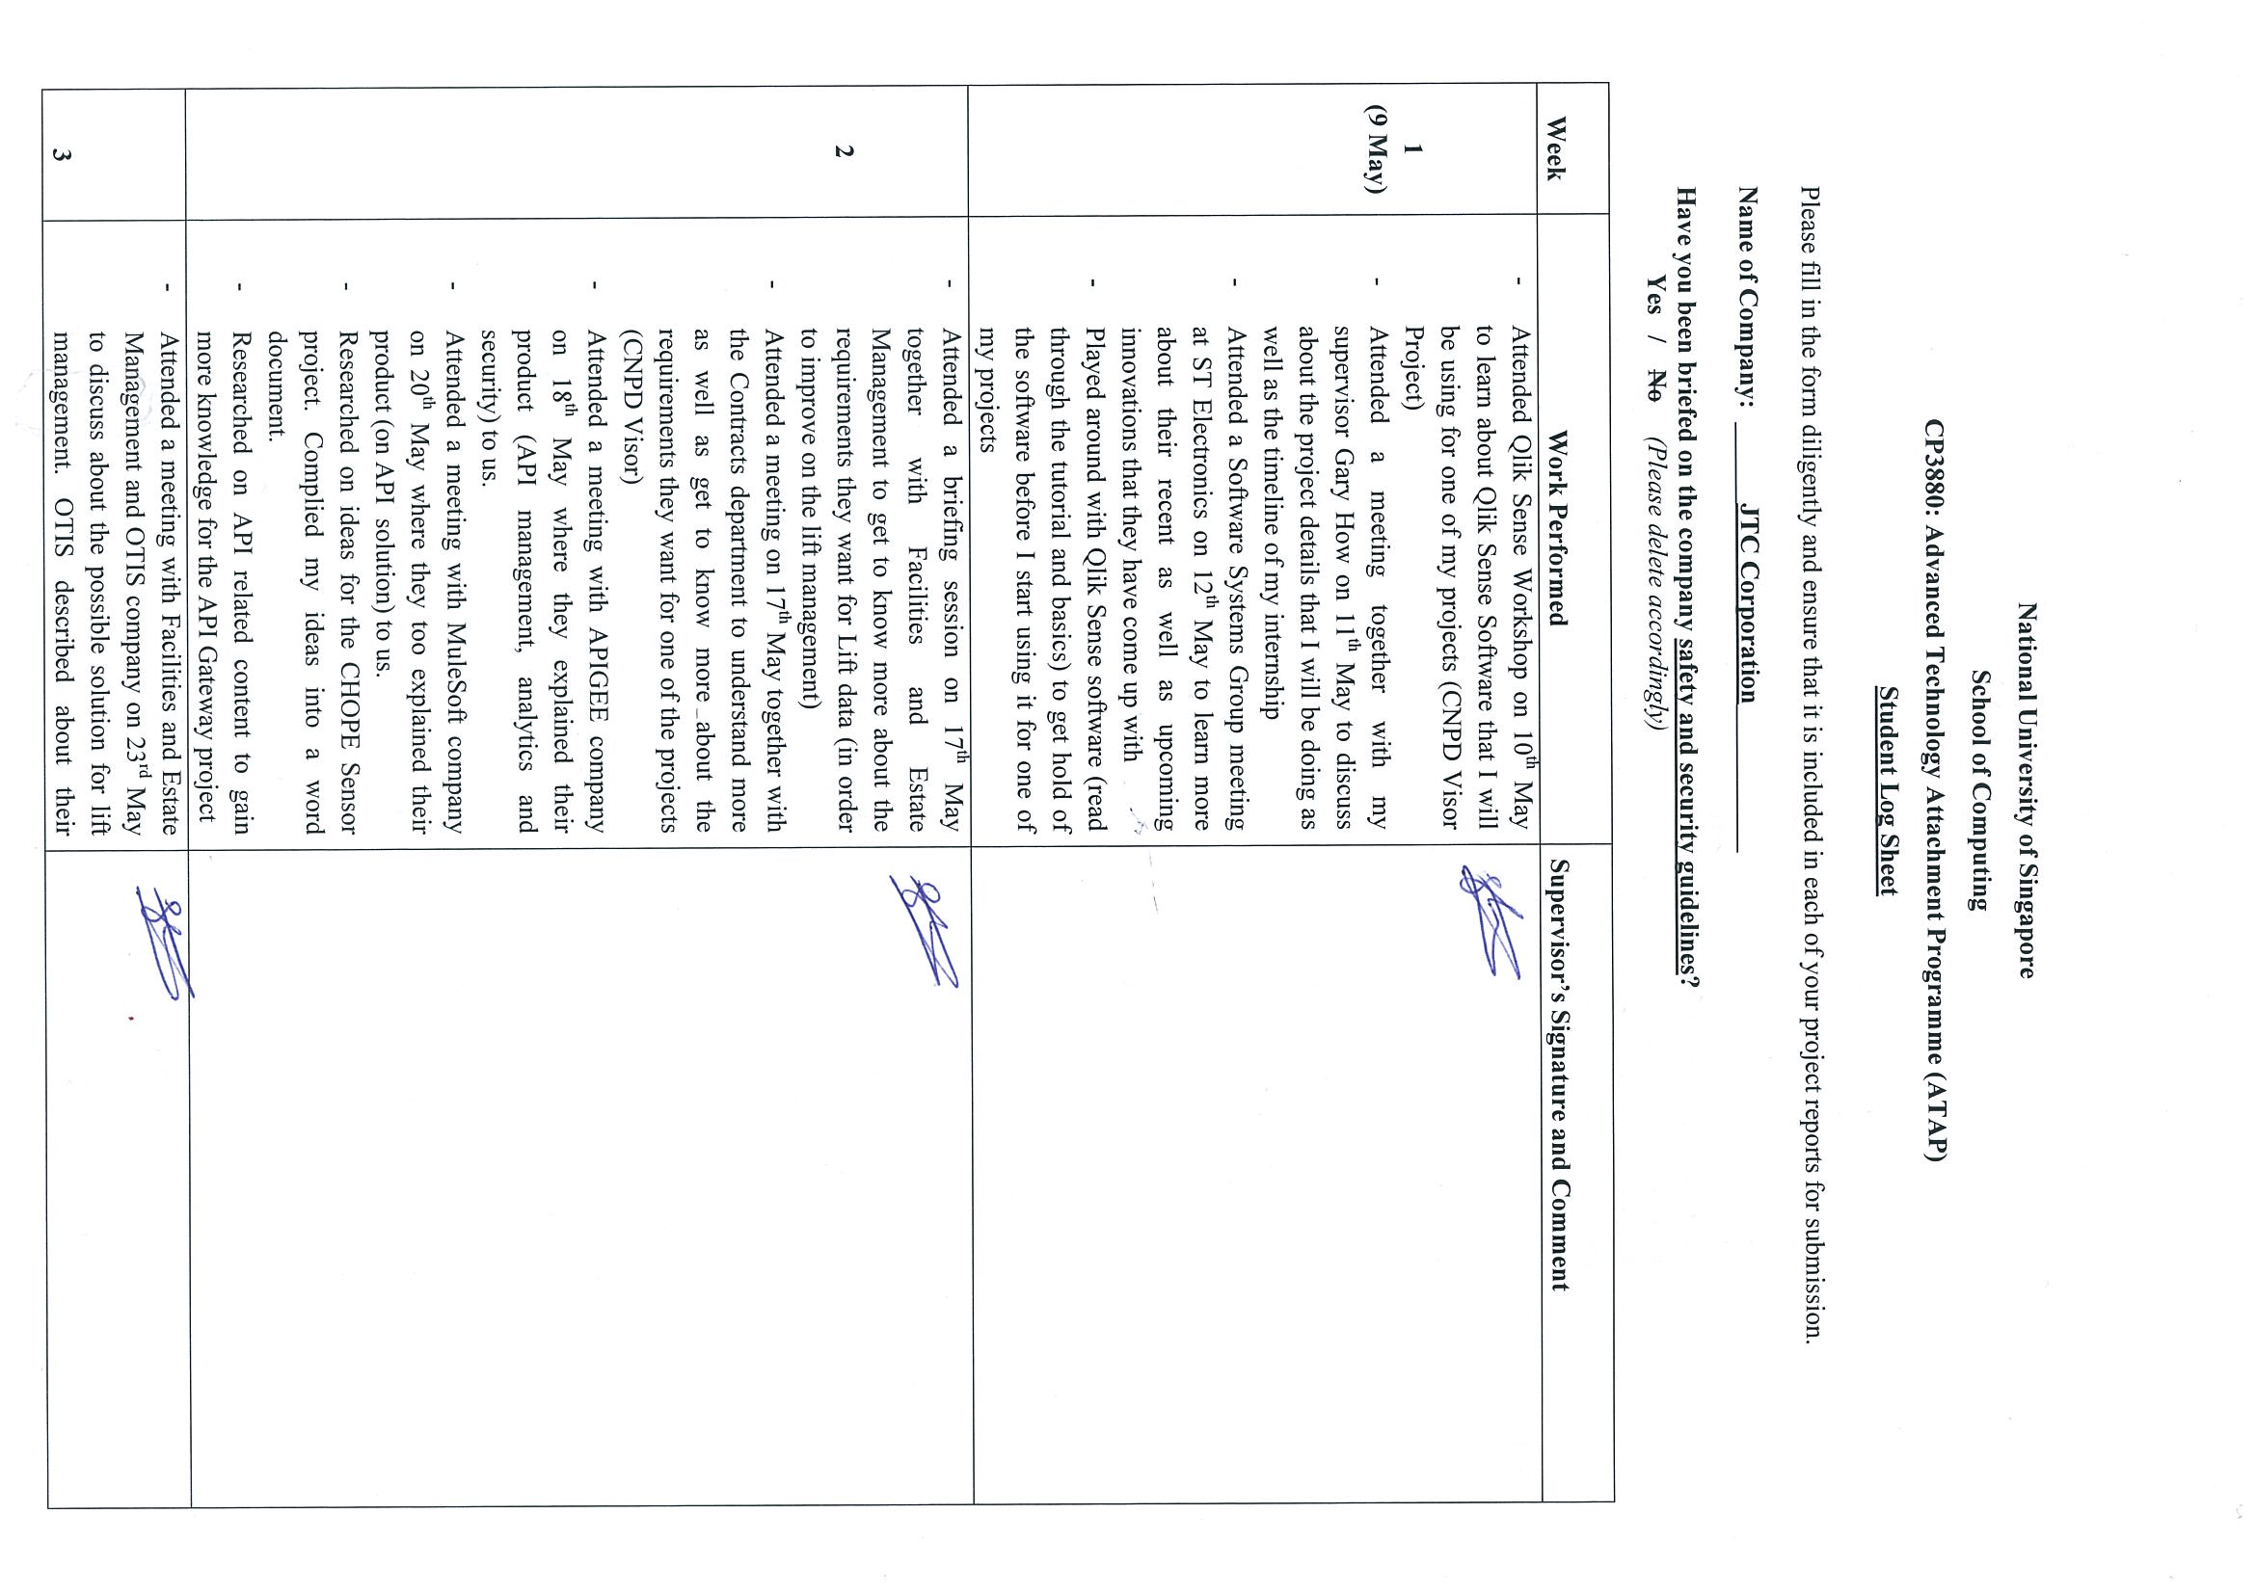

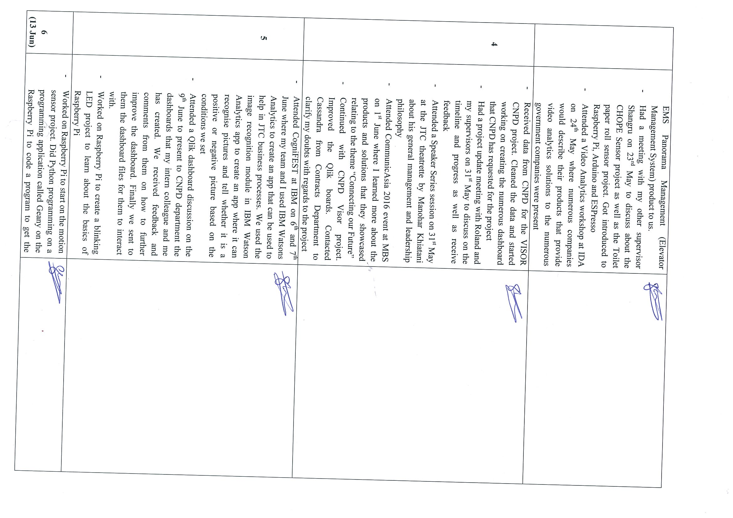

C:\Users\sohsxa-jtc\AppData\Local\Microsoft\Windows\Temporary Internet Files\Content.Outlook\IOBG1W9A\img-X17165939-0003.tif

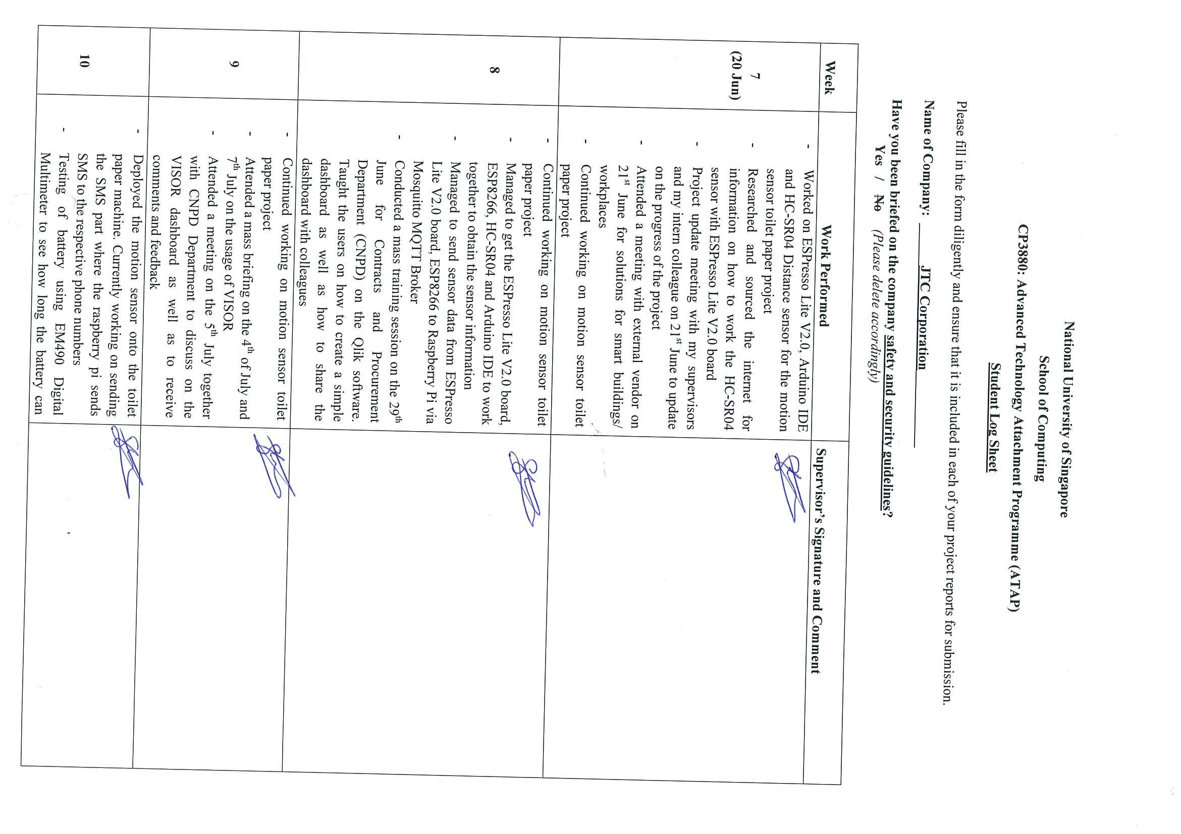

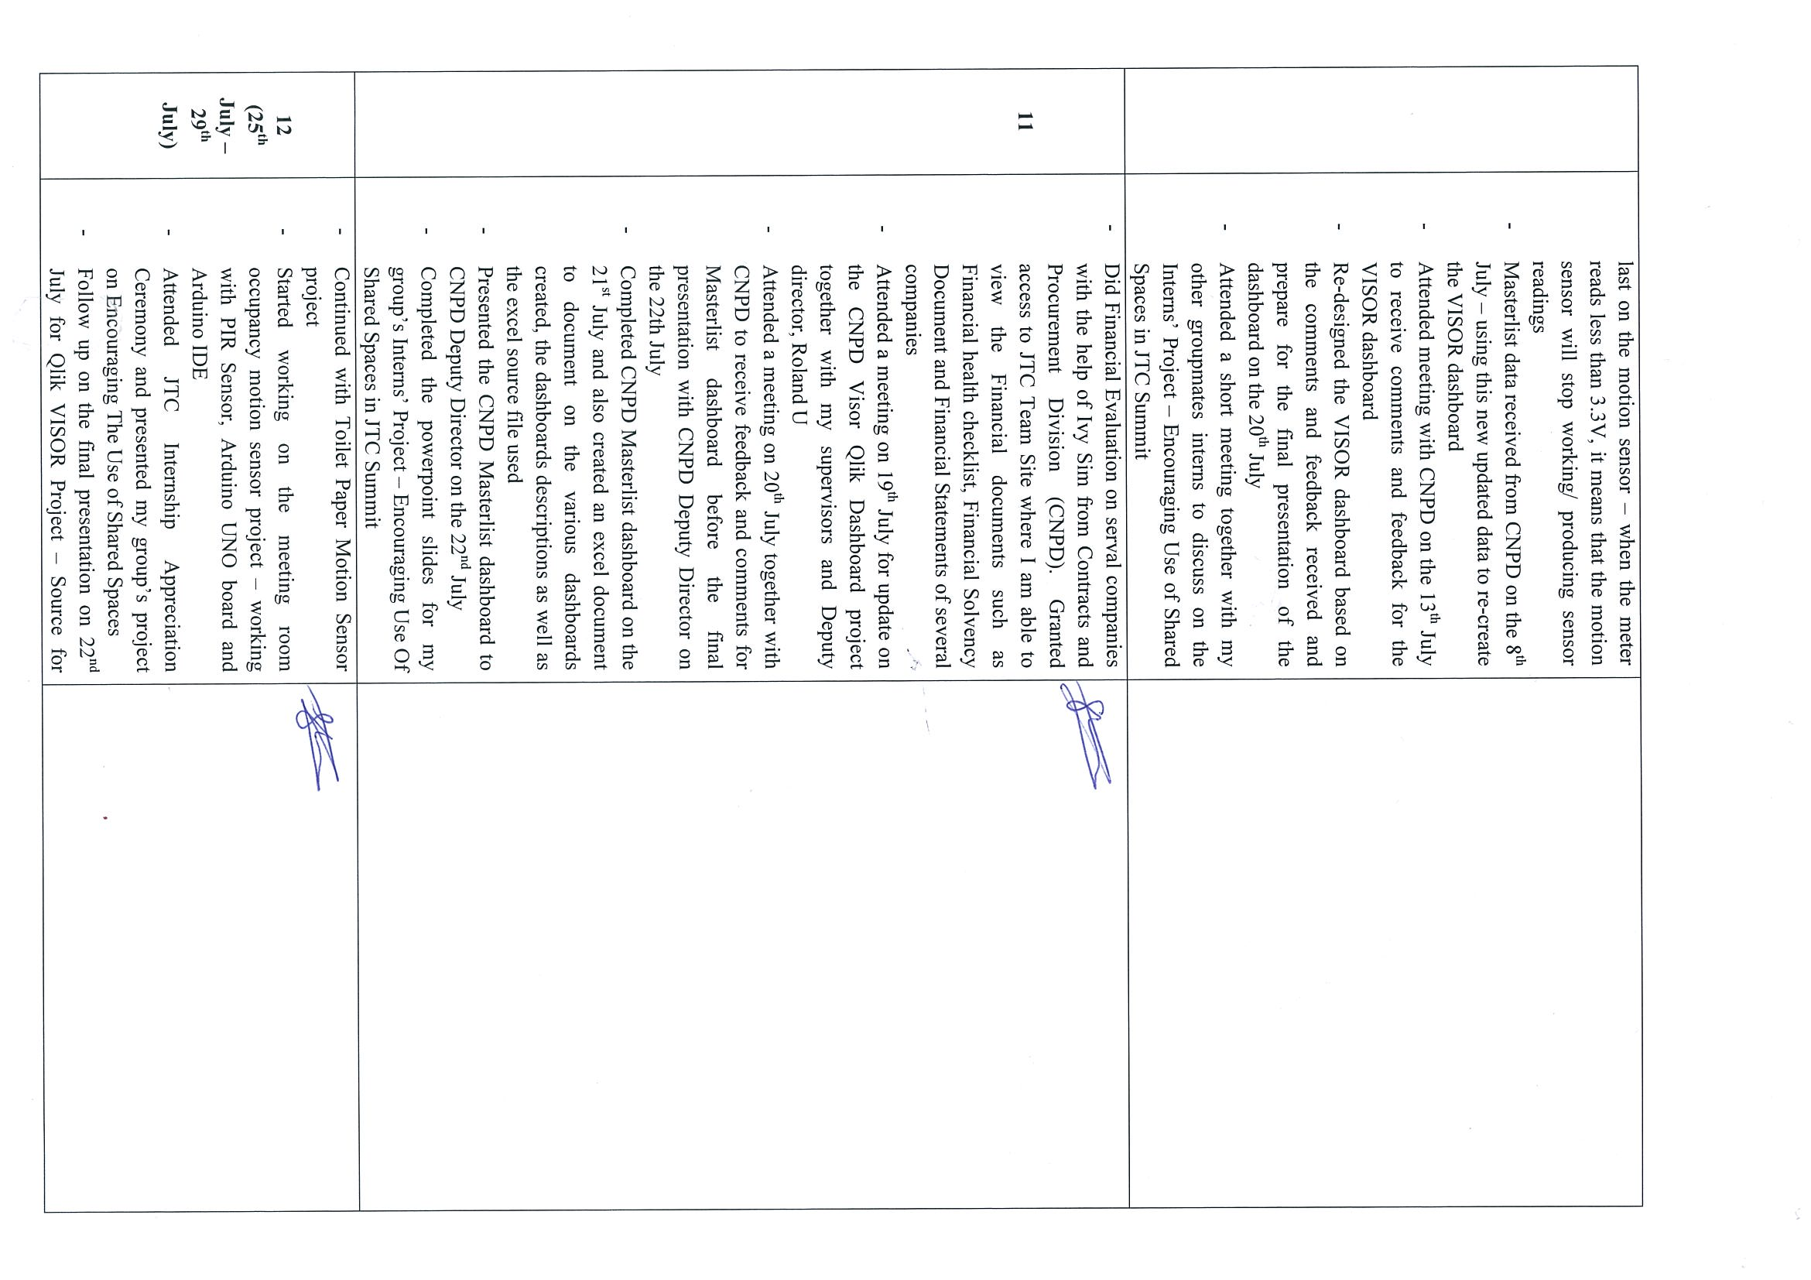

C:\Users\sohsxa-jtc\AppData\Local\Microsoft\Windows\Temporary Internet Files\Content.Outlook\IOBG1W9A\img-X17165942-0006.tif

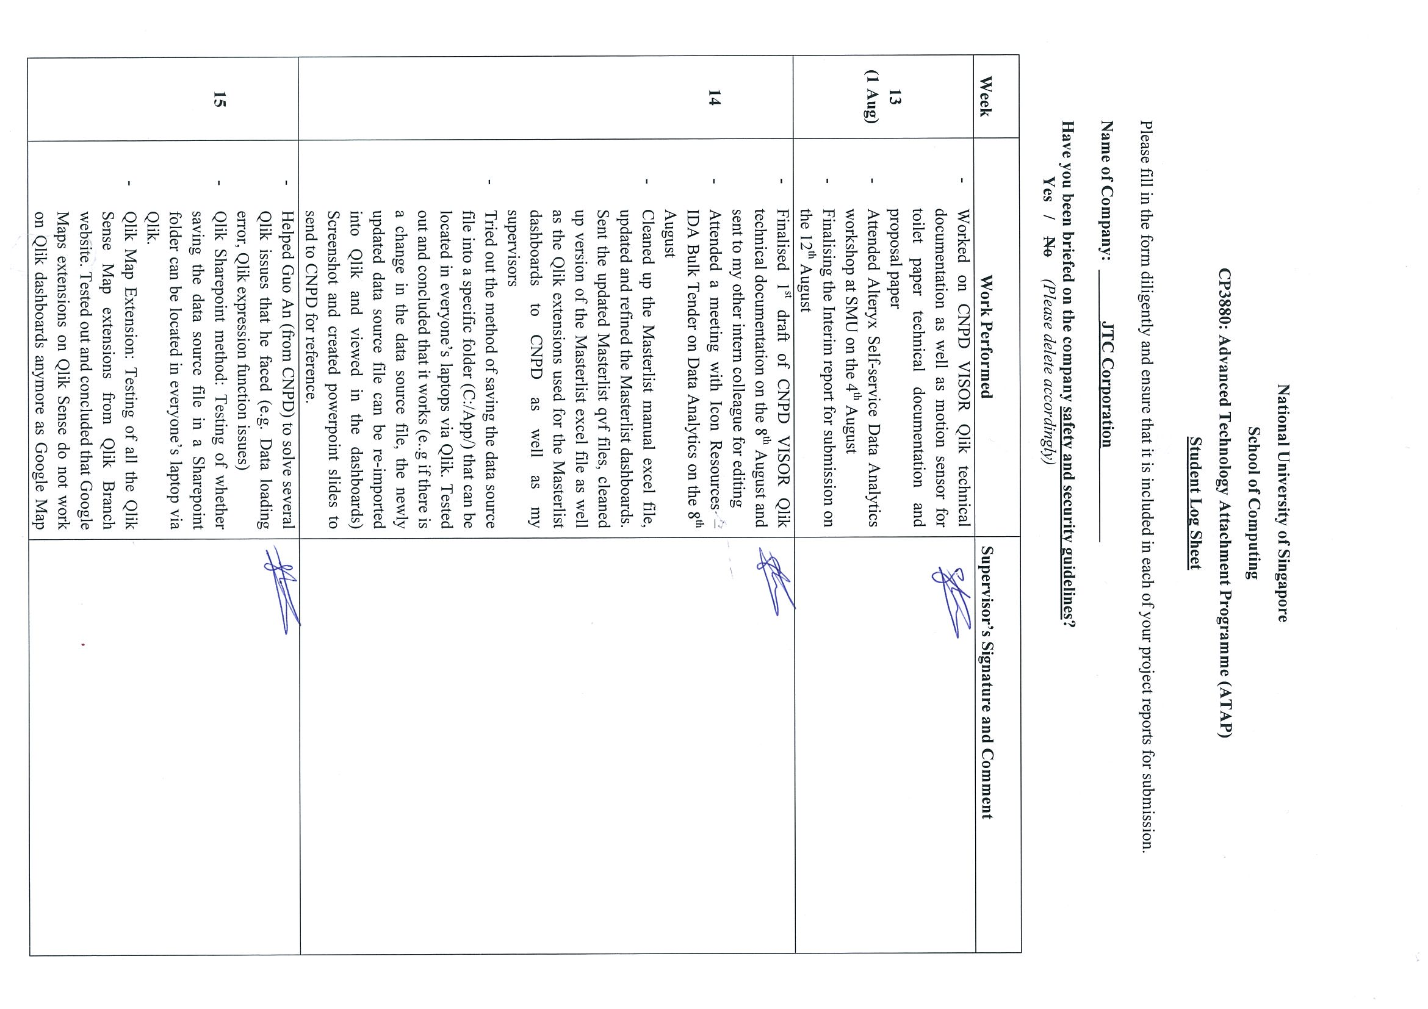

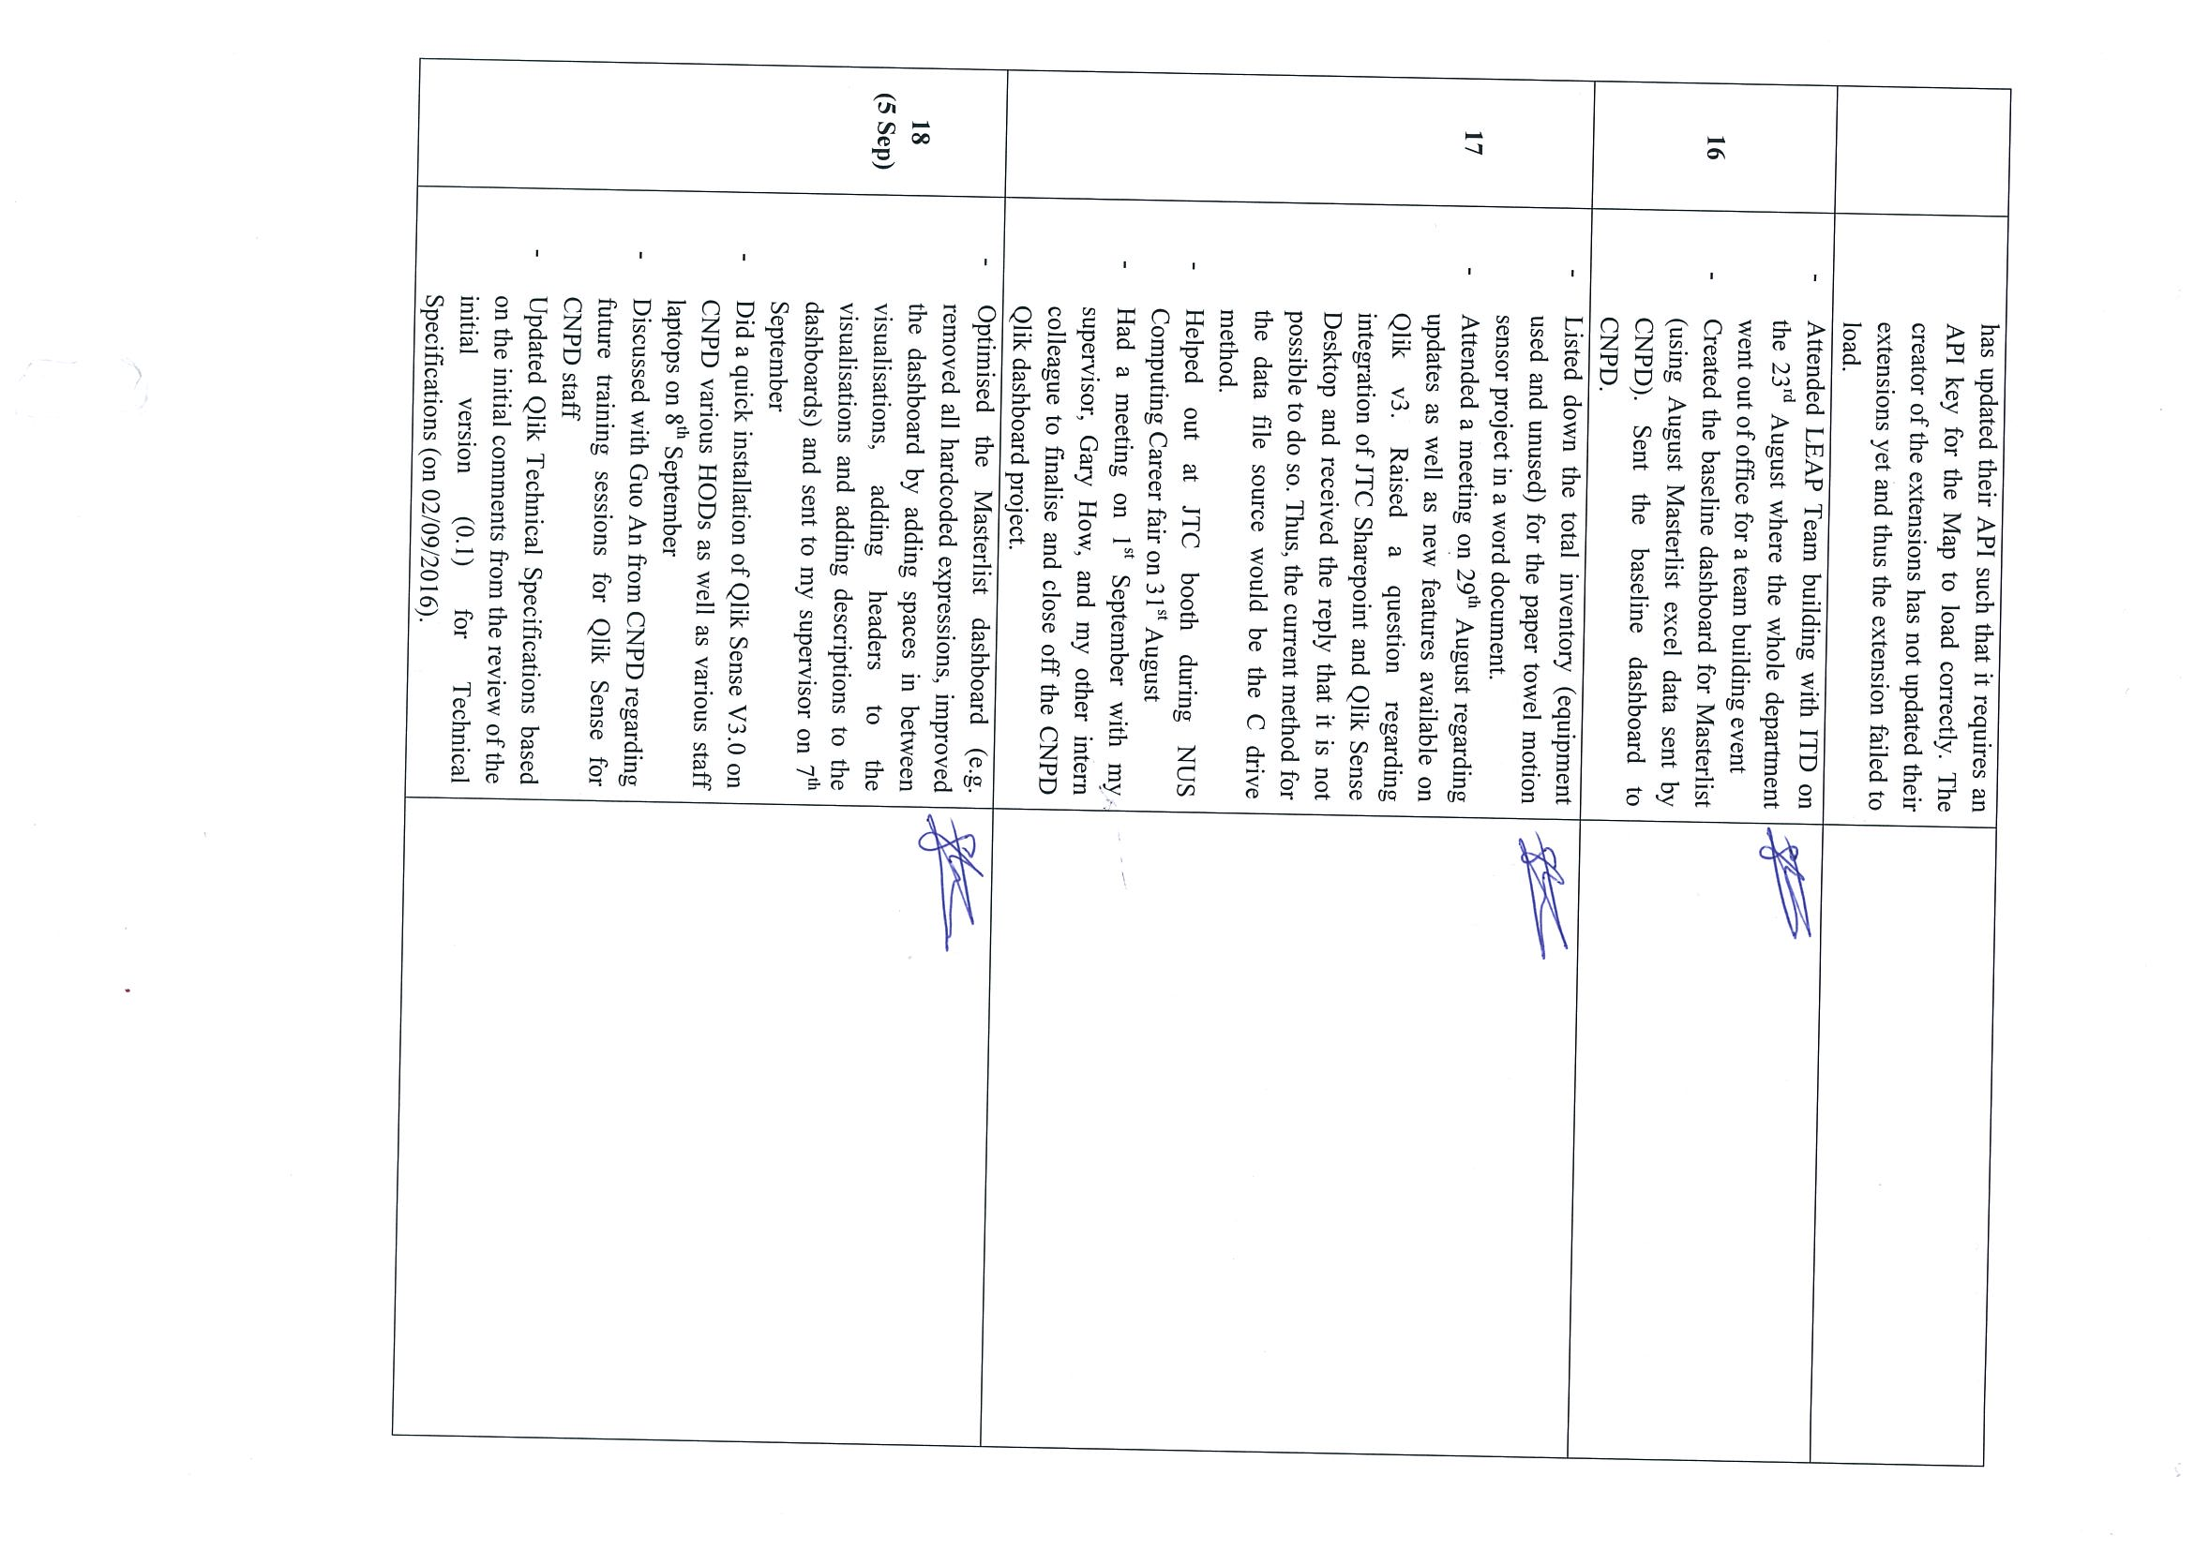

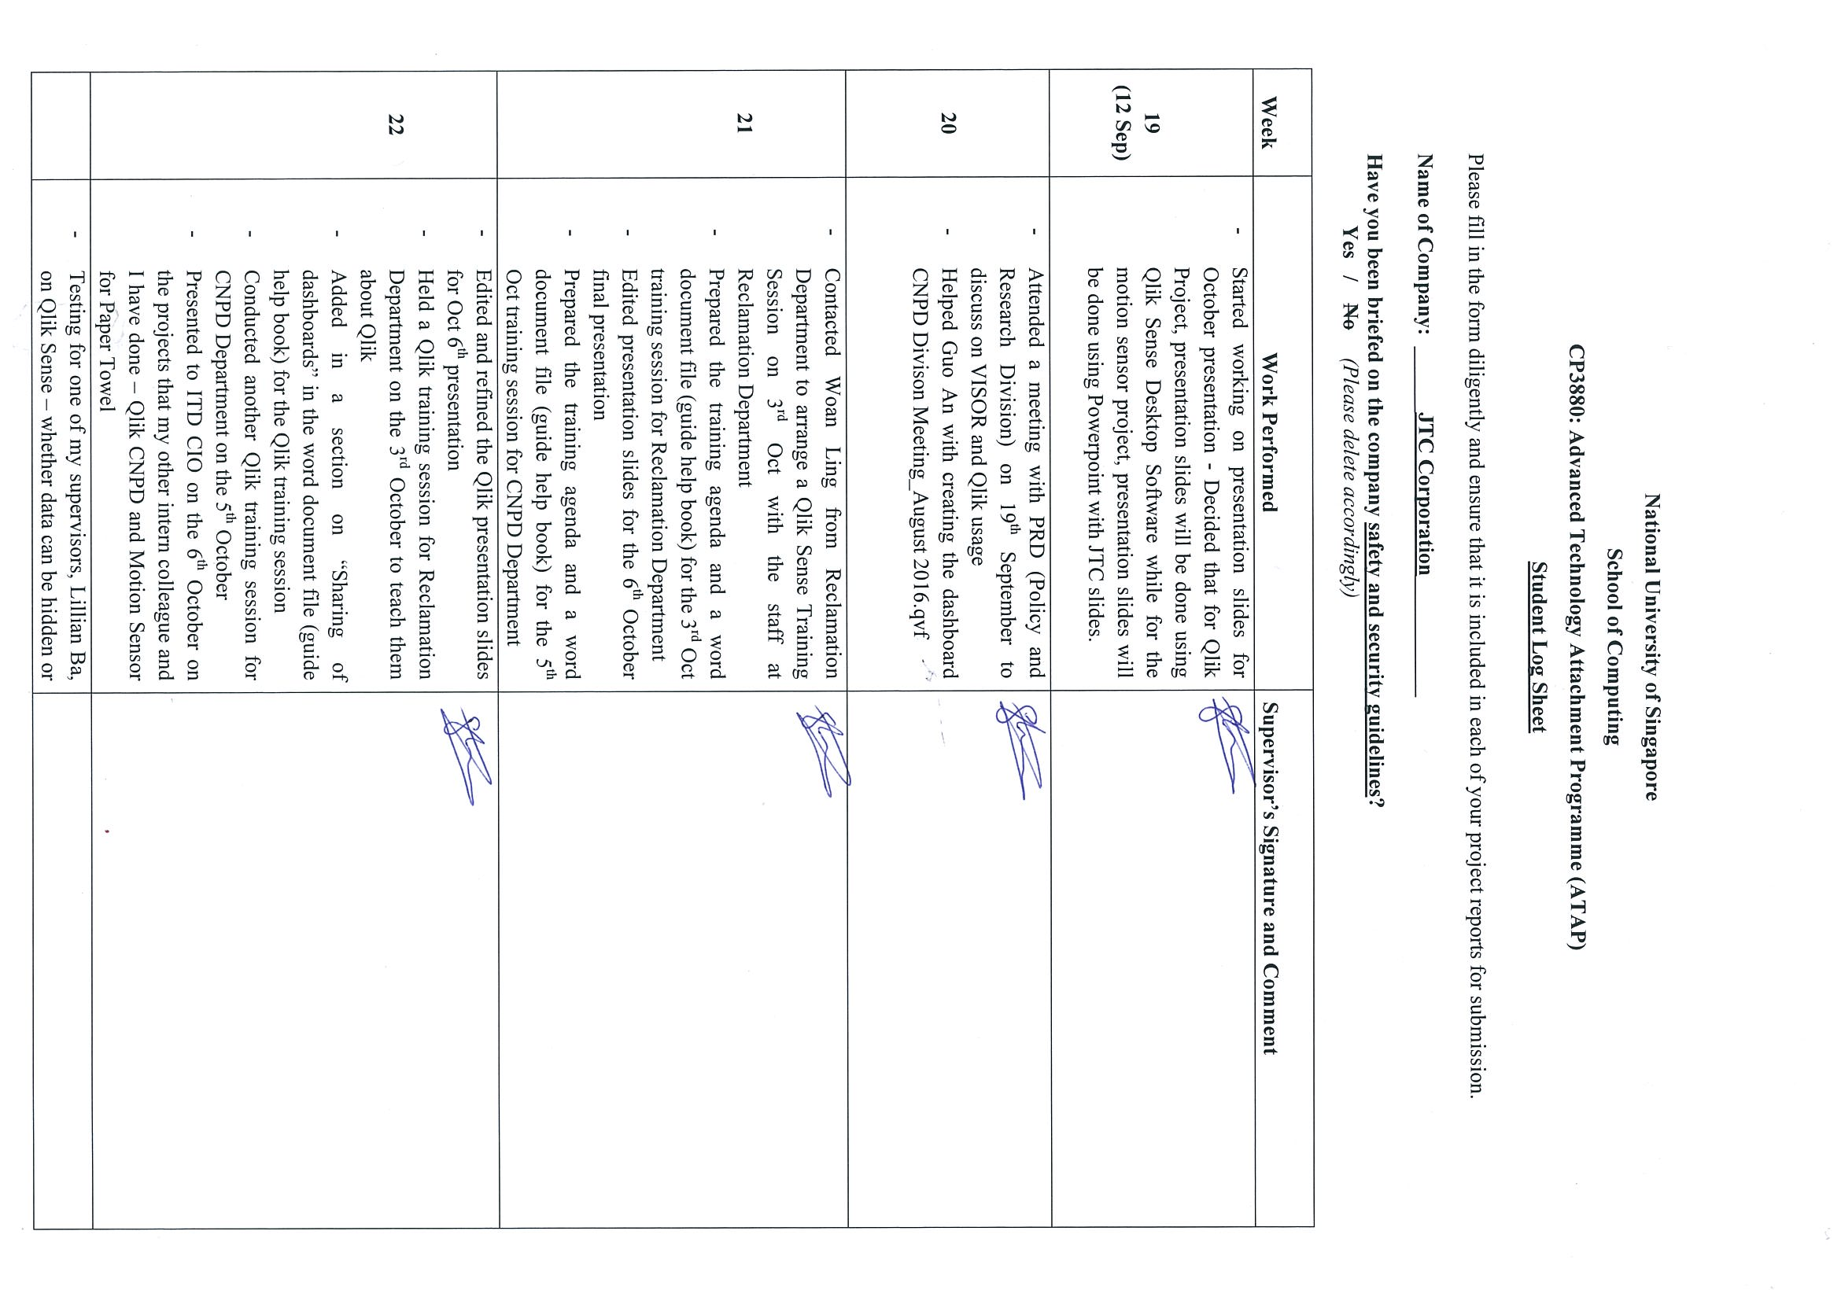

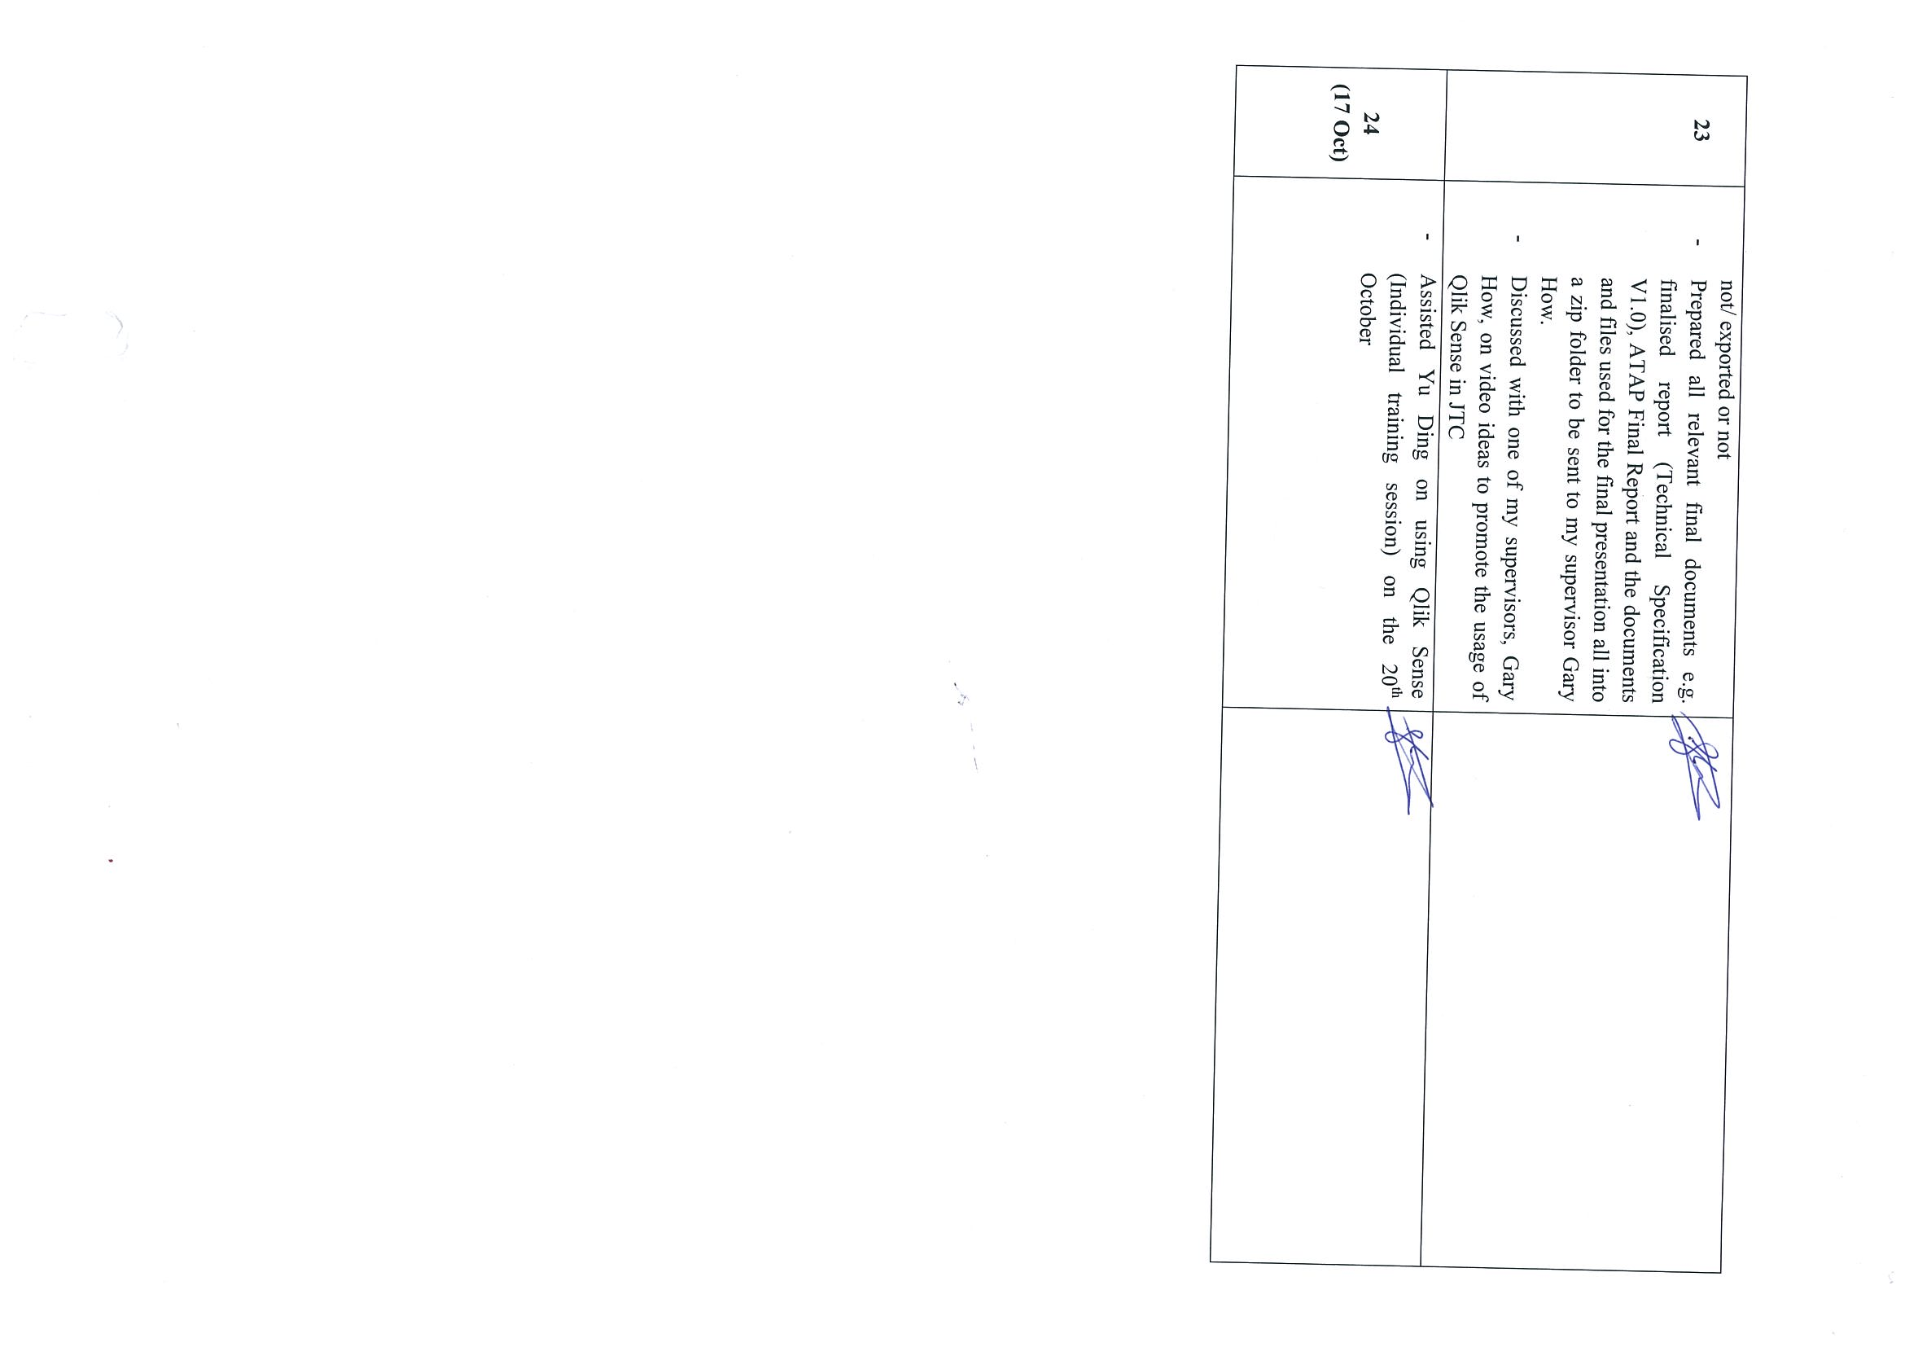

# ATAP Report Clearance Form

